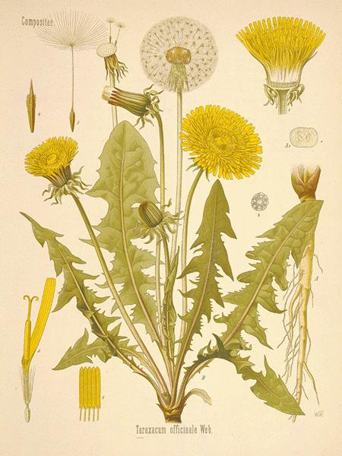Herb Series: The all-powerful gardens “weed” *Dandelion*

When spring rolls around Dandelion seems to be a hot topic of conversation. Any time someone talks about weeding Dandelions I have to admit I wince a little.

With its popular reputation as an overtaking weed, it’s not often recognized for its powerful medicinal properties.

**Material Medica:** Dandelion

**Latin name:** *Taraxacum officinale*

**Family:** Asteraceae

**Parts used:** All (leaf, flower, root and sap)

**Uses:**

Dandelion is known for being a liver and kidney tonic. It aids digestion, helps with breast tumors, abscesses, boils, fluid retention, stomach disorders and constipation. (1). It is one of the best remedies for hepatitis and potentially a preventative for breast cancer.

Emotionally releases tension, balances and puts one more in tune with self.

Studies have proven Dandelions effects on reducing inflammation and increasing bile production. A study done on mice has shown dandelion extract to up-regulate estrogen, progesterone and follicle-stimulating hormone receptors (6). Another study showed a 32% success rate in curing Hepatitis B (6).

**Cautions:**

Dandelion has very few reported cases of contraindications. As with any plant there is the potential of an allergic reaction (5). Lower dose and use with caution while pregnant or nursing.

There have been few cases of Dandelion causing abdominal discomfort, loose stools, nausea and heartburn (5).

**Sources:**

1. Tierra, Michael, and David Frawley. *Planetary Herbology: An Integration of Western Herbs into the Traditional Chinese and Ayurvedic Systems*. Twin Lakes, WI: Lotus, 1988. Print.

2. Edwards, Gail Faith. Opening Our Wild Hearts to the Healing Herbs. Woodstock, NY: Ash Tree Pub., 2000. Print.

3. Moore, Michael. *Medicinal Plants of the Mountain West*. Santa Fe: Museum of New Mexico, 2003. Print.

4. Kaminski, Patricia, and Richard Katz. Flower Essence Repertory: A Comprehensive Guide to North American and English Flower Essences for Emotional and Spiritual Well-being. Nevada City, CA: Flower Essence Society, 1994. Print.

5. Mars, Brigitte. *The Desktop Guide to Herbal Medicine: The Ultimate Multidisciplinary Reference to the Amazing Realm of Healing Plants, in a Quick-study, One-stop Guide*. Laguna Beach, CA: Basic Health Pub., 2007. Print.

6. Yarnell, E., and K. Abascal. "Dandelion (Taraxacum Officinale and T Mongolicum)." Integrative Medicine: A Clinician's Journal (2009): 34-36. Web.